**Decision Tree for LOAN Project**

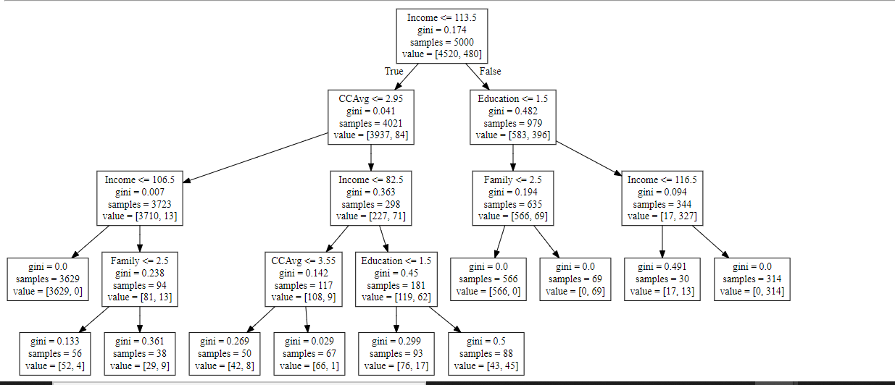

**From above we can conclude the rules as follows:**

1. If Income <= 106.5 and CCAvg <= 2.95, then the person did not accept the personal Loan.
2. If 106.5<=Income< 113.5 and CCAvg<= 2.95 and Family Size<= 2.5, then the % of persons who did not accept the Loan= 52/56 = 0.92
3. If 106.5<=Income< 113.5 and CCAvg<= 2.95 and Family Size> 2.5, then the % of persons who did not accept the Loan= 29/38 = 0.76
4. If Income <= 82.5 and 2.95<= CCAvg <3.55, then the % of persons who did not accept the Loan= 42/50 = 0.84
5. If Income <= 82.5 and CCAvg > 3.55, then the person did not accept the personal Loan
6. If 82.5<= Income <113.5 and CCAvg > 2.95 and Education <=1.5 , then the % of persons who did not accept the Loan= 76/93 = 0.81
7. If 82.5<= Income < 113.5 and CCAvg > 2.95 and Education > 1.5 , then the % of persons who did not accept the Loan= 43/88 = 0.48
8. If Income > 113.5 and Education <= 1.5 and Family <= 2.5, then the person did not accept the personal Loan.
9. If Income > 113.5 and Education <= 1.5 and Family > 2.5, then the person did accept the personal Loan.
10. If 113.5 < Income <= 116.5 and Education > 1.5, then the % of persons who did not accept the Loan= 17/30 = 0.56
11. If Income >116.5 and Education > 1.5, then the person did accept the personal Loan.